**10 Things to do!**

1…………………………………………………………………………………………

2…………………………………………………………………………………………

3…………………………………………………………………………………………

4…………………………………………………………………………………………

5…………………………………………………………………………………………

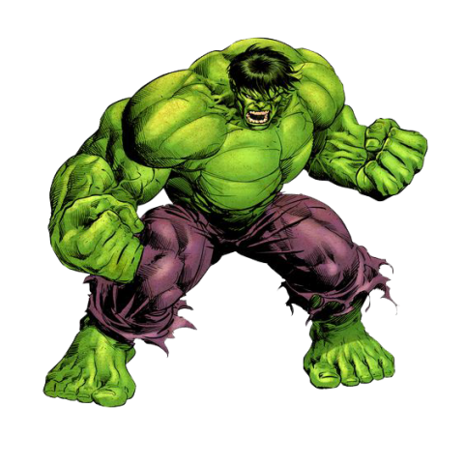6…………………………………………………………………………………………

7…………………………………………………………………………………………

8…………………………………………………………………………………………

9…………………………………………………………………………………………

10…………………………………………………………….…………………………

Hulk Version

Rev.3 By Chatchanok K.

**10 Things to do!**

1…………………………………………………………………………………………

2…………………………………………………………………………………………

3…………………………………………………………………………………………

4…………………………………………………………………………………………

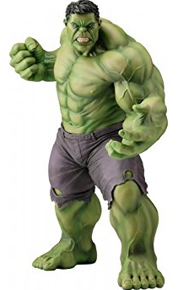5…………………………………………………………………………………………

6…………………………………………………………………………………………

7…………………………………………………………………………………………

8…………………………………………………………………………………………

9…………………………………………………………………………………………

10…………………………………………………………….…………………………

Hulk Version

Rev.3 By Chatchanok K.